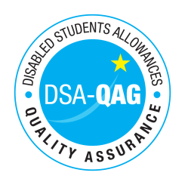
City, University of London - NMH Rates

Period covered - 01/04/2018 through to 31/03/2019

The table below shows NMH rates. The greyed out cells indicate that the NMH provider does not offer these services.

Note: NMH Support Rates shown per hour in the table below.
 | Standard Rate (in-person) |  |  | Distance Learning only (in-person, in-home) |  |  | Remote Delivery (e.g. Facetime/Skype or similar) Only
Band 1 Support Assistants | Net | VAT | Total | Net | VAT | Total | Net | VAT | Total
Practical Support Assistant
Library Support Assistant
Reader
Scribe
Workshop / Laboratory Assistant
Sighted Guide
Proof Reader
Band 2 Enhanced Support Assistants
Study Assistant
Examination Support Worker
Manual Note Taker
Band 4 Specialist Access and Learning Facilitators
Specialist Mentor (Mental Health Condition) | 60.00 |  | 60.00 |  |  |  | 60.00 |  | 60.00
Specialist Mentor (AS) | 60.00 |  | 60.00 |  |  |  | 60.00 |  | 60.00
Specialist One-to-One Study Skills Support (SpLD) | 60.00 |  | 60.00 |  |  |  | 60.00 |  | 60.00
Specialist One-to-One Study Skills Support (AS)

